
SYSTEMS DIVISION
Security Architecture

REVISED
Prepared By:

Linda Gerdes
Sundar Narayanan
John Parkolap
Rich Gracyzk
Tatiana Kudina
10-Mar-2004

File Name: | 0000.doc
Document  Reference: | Security Architecture
Version: | Version 1.0
Status: | Revised

Contents
Introduction 4
1. Jetty Web Service 5
2. MVC Struts 6
3. Security 7
3.1 Application Security Management Service (ASMS) 7
3.2 User Authentication 8
3.3 User Session Management 10
3.3.1 Session Timeouts 11
3.4 Business Service Access Level Security 11
3.5 Client Level Security 14
3.5.1 Menu Level Security 14
3.5.2 Page Access Security 15
3.5.3 Page Level Security 15
3.6 Role Management 16
3.6.1 Process Flow 17
3.7 Infrastructure Security Service 20

Introduction

This document describes security involved in designing a web-based application using Jetty web service employing Struts MVC. The back end of the web based application would be business services deployed using the foundation framework. This document also addresses how Application Security Management Service (ASMS) addresses both client and server side security issues.

Jetty Web Service

The Jetty is an open source Java HTTP Server and Servlet Container. When the browser posts a request, Jetty uses Jasper service to translate the jsp file into java code. Jetty also acts as a container hosting the Struts ActionServlet. When the path of the request matches the servlet context in the ActionServlet, the jetty container forwards the request to the ActionServlet.

Jetty Web Server will be bundled into a service by the infra structure group. This service will be instantiated as part of our business service. Jetty Service will also take care of maintaining a unique HTTP session ID for each session

MVC Struts

When the Struts ActionServlet receives a request from Jetty, it runs the request through a gauntlet that processes the locale, mapping, form bean and finally the action. Each use case in the system has an associated Controller Class, View Class and a model class. The model classes communicate with the business services to query and update information based on user requests.

View
(Form Classes)

Controller
(Action Classes)

Model
(Model classes)

Business Services

Jetty Service

Servlet

Browser
Application

The backbone component of the struts framework is the Action Servlet. This servlet will be contained in the Jetty container.

Security

Security is very important when deploying web applications. Security is handled in multiple ways.

Application Security Management Service (ASMS)

ASMS will be a new service developed to take care of security. ASMS plays a major role in providing security for web applications. ASMS will interact with the existing Infrastructure Security Service to assist in authentication and service level access. Please refer to Infrastructure Security Service documentation for more information about the Security Service.

ASMS is responsible for both client and business service security. ASMS has two major responsibilities

- Security Manager

- ASMS will validate the user ID and password with the security Service
- ASMS will provide client menu access based on the roles that a user ID belongs to

- Session Manager

- ASMS will maintain a memory mapping of HTTP Session ID, User ID, Security Session ID, roles and last access time
- ASMS will provide the security session ID if the HTTP Session ID is supplied
- ASMS will time out sessions that have been idle for a business defined period

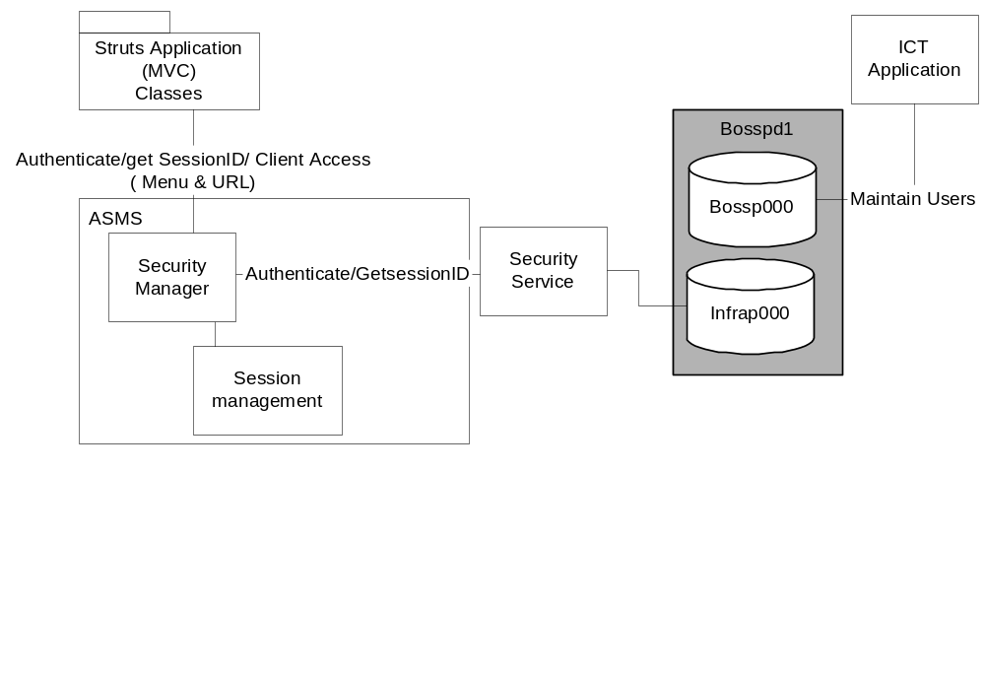

User Authentication

Every user who needs to use the GUI must login with their user ID and password, which is then validated by the system. Only authenticated users are allowed to use the system. If the user is not authenticated, they are prompted to submit the correct login information.

The following describes the processes involved in maintaining a user ID and password

- Each user using the system is assigned a unique user ID, password using ICT application.
- The data for the users are stored in oracle tables. The password is stored in an encrypted format. Refer to section 3.6 for details about how roles are managed.
- Any updates to the oracle tables are transmitted to security activity tables using appropriate triggers
- The Security adapter periodically checks the security activity tables for any new entries. If it finds any new entries it retrieves the modified entry appropriate user tables for the modified entry.
- It transmits the information to the infrastructure Security Admin service
- The Security Admin Service will then transmit the information to security service
- Security service will store this information in its internal database

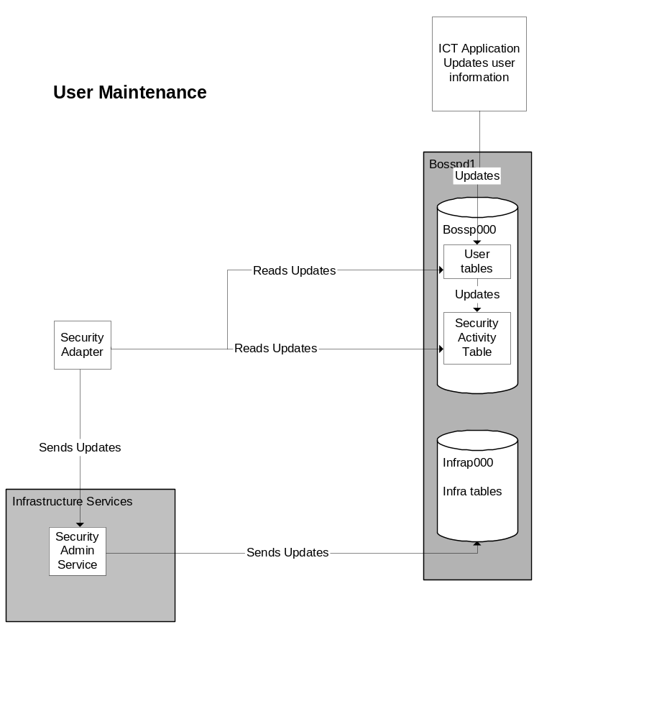

The following describes the processes involved in authenticating a user

- User submits the user ID and password using the login web page
- The request is received by Jetty service and Jetty Service forwards the request to the Struts action servlet
- Struts Action Servlet sends the request to the MVC struts class
- The Login Model class in the MVC will then send a request to ASMS to authenticate the user
- ASMS will submit an authenticate request to the Infrastructure Security Service
- The Security Service authenticates the user and informs the ASMS about the validity of the user
- ASMS passes this information back to Login Model class
- The controller upon receiving successful authentication will then forward the user to their appropriate default web page
- The controller upon receiving unsuccessful authentication will display a system error message requesting the user to submit their correct credentials

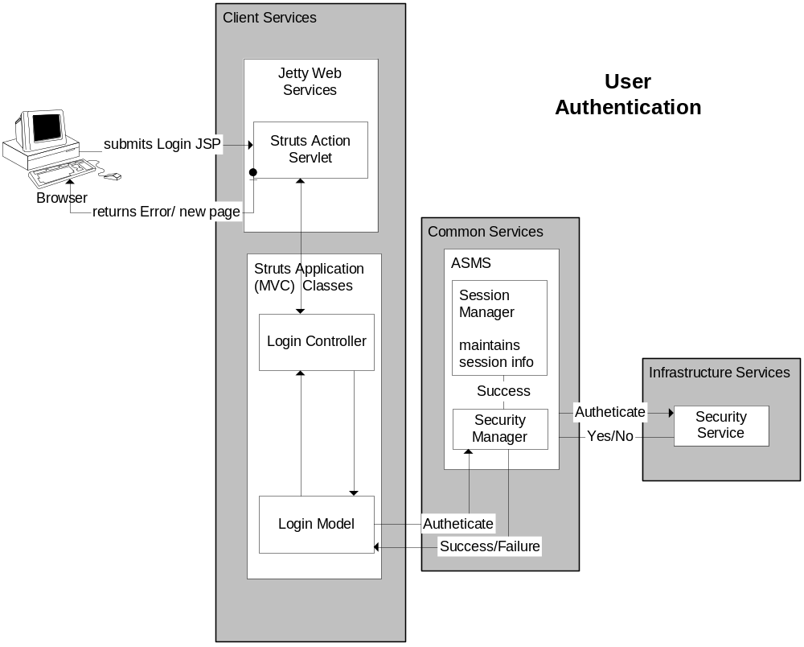

User Session Management

With web applications session management becomes very critical in order to identify the user involved. Jetty provides a unique HTTP session ID per application that remains valid till the user closes the web page. Security Service maintains a security session ID that gets assigned upon authentication and remains valid until the user logs off. ASMS will act as a bridge between Security session ID and HTTP session ID.

- When a user logs in to application, they submit their login information.
- This information is read by the Jetty service and assigned a unique HTTP session ID
- Jetty passes this information to the Struts MVC classes.
- The model class then submits the user ID, password and HTTP session ID to ASMS to authenticate.
- ASMS validates the user ID, password with Security Service
- Security service upon successful authentication returns back the security session ID and roles back to ASMS
- ASMS Session Manager will maintain a hash mapping table containing the following for each user as shown in the figure above
  - User ID
  - Roles (a comma delimited list if there are more than one roles that a user is associated with)
  - HTTP Session ID
  - Security Session ID
  - Last Action Time
- ASMS returns a success message to Model
- The model class would forward the user to their corresponding default page
- Any subsequent requests from the users will funnel through ASMS
- The Model classes would request the ASMS to provide security session ID for calls to the business services
- ASMS upon receipt of the request for Security session ID will verify the hash table for the HTTP Session ID and update the Last Action time and return back the Security Session ID to the model classes

Session Timeouts

Since a web application does not really have a compulsory logout procedure, the hash-mapping table could be out of synch if the user just closes the web page without logging out.

Security Service by default can be assigned a time out wherein if there is not any activity for a session, the session is invalidated and the users would have to login again. Since Security Service is a common infrastructure service and has a potential to be reused by multiple applications, a common time out might be much higher than each applications’ time out. For these reasons ASMS addresses the time out issue

ASMS is configured with a default time out set in the ASMS configuration file. ASMS periodically will parse the hash table and check if a session is active based on the time out and last action time. If the time difference between the current time and last action time is greater or equal to the time out, ASMS will invalidate the user entry. ASMS will also communicate with security service to log the user out of security service. Any subsequent calls by the user for services will be rejected by ASMS and the struts Controller will prompt the user back to the login screen to be authenticated again.

Business Service Access Level Security

Business Services may be implemented as CORBA services available to everyone. It is very important that only authorized users are allowed to access services and invoke the functionality of the services. The foundation framework provides a strong role based security structure that allows only authorized users to access services and invoke the functionality of the services.

Each user is assigned one or more roles that they belong to. Business Services security is configured primarily by roles. Each method in a service is assigned roles that can invoke them.

For example assuming that we have two roles

- Manager
- Analyst

Lets assume a service Business Service1 having two methods

- ChangeParms
- GetBusinessData

Each method will then be assigned roles

- ChangeParms – Manager
- GetBusinessData – Manager, Analyst

This information is provided to the security service, which stores it in its internal database. The information is provided in an excel sheet to the infrastructure group. The Infrastructure group will load this information into their internal database. If an Analyst invokes Business Service1.ChangeParms method, the security service will reject the call.

This method level security is implemented in BOInterceptors with a call to security service with the user’s security session ID. The security service will return the appropriate permission level (Yes or No) based on the rights that the user has.

The Security Session ID plays an important role in determining if the user has permissions or not. The business Interceptor needs the security session ID to pass to the security service to validate the method level access. ASMS using the hash table mapping provides the security Session ID.

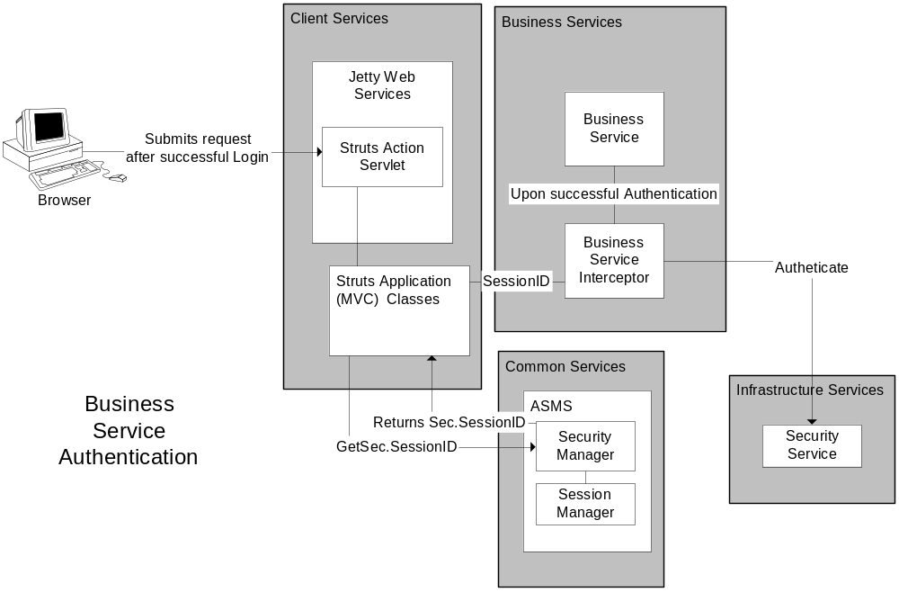

Client Level Security

Client level Security provides security on the client presenting users only with the menus and pages that they have access to. There are three layers of security in the client

- Menu Level Security – Involves presenting users only with menus that they have access to
- Page Access Security – Involves presenting users with pages only if they have access to
- Page Level Security – Security within a page for e.g. Managers can write, Analysts can only read.

Menu Level Security

Menu Security is implemented using Struts-Menu. Struts-Menu is an open source plug in that allows creation of many different menu systems from an XML file.

Struts Menu security is done at the role level. Each and every menu item is defined in an XML file. Each Menu Item definition has an optional “roles” attribute, which can be comma-separated list of all the roles that will be permitted to use a particular menu or menu-item.
Struts Menu comes with a single concrete implementation of the PermissionsAdapter, called RolesPermissionsAdapter. This adapter maps the user's security roles as defined in the application/ App-Server configuration against a list of permitted roles defined for each menu/menu item in menu-configuration file. This interface has one method: "isAllowed(MenuComponent)" that is called for each menu and menu item when the menu is being drawn. If it returns true, then the item is drawn on the page, if it returns false, then the item is not drawn.

<Menu name="PrefsMenu" title="Preferences" roles="User">
<Item name="UserPrefs" title="User Preferences" page="prefs.do"/>
<Item name="ModPrefs" title="Moderator Preferences"
page="modPrefs.do" roles="Moderator System"/>
<Item name="AdminPrefs" title="Site Preferences"
page="sitePrefs.do" roles="System"/>
</Menu>

The menu configuration will be done in the configuration file. The menu is visible to anyone in the User role, who then gets access to User Preferences automatically. Anyone in the System or Moderator roles can access the moderator preferences, but the site preferences are limited only to System-level users.
The roles defined in the configuration file will be the same as the roles defined in ICT application and Security Service. If a new role is added, then the configuration file has to be modified to reflect the menus that the users in the new role have permission.
Sample code is shown below for coding the security in RolesPermissionAdapter class

Public boolen isAllowed(MenuComponent menu)
{
if (menu.getRoles() == null) {
return true // No roles defined. If there is functionality that is common across all //users then no roles are defined in the menu item allowing everyone to see the //menu item
} else
{
String[] allowedRoles = StringUtils,split(menu.getRoles(),’’,”); // this will retrieve all the / //roles that the menu item has rights to
For each role in allowedRoles()
{
The ASMS will be invoked and then passed the HTTP Session ID and the menu access role.
ASMS will use its hash-mapping table to verify if the user belongs to the role. If it finds a match then it returns true else it returns false
If ASMS returns true, then return true otherwise continue with the looping
}
}
return False to indicate user does not have access
}

Page Access Security
The user by default does not get to see the menu items that their role does not have access to. The page level security comes into picture when the user does not belong to the role but has knowledge about the path of the menu item. This security will prevent the system from rendering the page if their role does not have access to the page.
The menu configuration file will be reused for page level security. Each menu item must have a page and a role associated with it in the menu-config.xml file.
<Item name="MaintainXX" title="Maintain XX Updates"
page="MaintXX.do" roles="Mgr"/>

If a user who does not belong to the role “Mgr” but has knowledge of “MaintXX.do” then they are prevented from accessing the page. If they type the address in the web page, their role will be validated against the roles allowed for the page. If they don’t belong to the roles allowed, an error message will be prompted to the user and log created for the same.
The validation will be handled by ASMS with logic similar to menu level security.

Page Level Security
This security is defined inside a page. This is more specific to applications. A typical example is Parameter configuration. Managers are permitted to change parameters but Staff is not allowed to do so. Staff is allowed to see the parameters. This security will be implemented in the code.

Role Management

Roles play a very important part of the security. Menus, Pages and services are configured on the basis of roles that a user belongs to.

The Role assignment to users is done using Oracle tables. The following are the tables used in assigning roles to users.

- Staff_pers_t – This table is maintained by the ICT application. The table defines the user_name, password and relevant information about the user.

STAFF_PERS_USER_NAME | FIRST_NAME | LAST_NAME | STAFF_PERS_TYPE_CODE | PSWD_TEXT | EMAIL_ADDR
PEDRAZA | Richard | Pedraza | ANAL | 4Z3@^.^ | [NULL]
MATERNAJ | Jordan | Materna | MGR | S^WZ@+^C | [NULL]

- Dept_Area_t – This table is maintained by the ICT application. This table defines the various departments.

Dept_uid | Dept_area_code |  | Dept_area_name
503000 | 6 | MR-Floor Broker/DPM Review
503000 | 3 | MR-Insider Trading
503000 | 7 | MR-Market Integrity
503000 | 5 | MR-Market Manipulation

- Dept_Area_Asgnmt_t – This table is maintained by ICT Application. This table defines the role that a user has within a department. All regulatory users are assigned roles in this table.
Dept_uid | Dept_area_Code | Staff_pers_user_name | Dept_area_asgnmt_role_code
503000 | 3 | SIZEMOREP | SUPER
503000 | 3 | WERTSJ | STAFF
503000 | 3 | MILANJ | STAFF
503000 | 3 | BOUGHTONJ | STAFF
503000 | 3 | MATERNAJ | SUPER

Jordan Materna whose user name is MATERNAJ belongs to Market regulation group(503000) and MR-Insider Trading department(3)
This configuration is done using ICT Application. When a user has an entry in Dept_Area_asgnmt table then by default the user will have a role of “REGULATORY” in addition to all the other roles defined in this table.

- A new view REG_DEPT_ROLE will be created joining tables DEPT_AREA_T and Dept_Area_Asgnmt_Role to produce names for regulatory department roles (REG_DEPT_ROLE_NAME). REG_DEPT_ROLE_NAME is a concatenation of department area name (Dept_area_name) and assignment role code (Dept_area_asgnmt_role_code).

The role name is derived by
Reg_dept_role_name = Dept_area_name + '-' + dept_area_asgnmt_role_code.

All spaces and symbols '/', '&' and '.' are removed.

The table below lists some sample role name derivations

Dept_uid | Dept_area_Code | Dept_area_Name | Dept_area_asgnmt_role_code | Reg_dept_Role_name
503000 | 3 | MR-Insider Trading | SUPER | MR-InsiderTrading-SUPER
503000 | 3 | MR-Insider Trading | STAFF | MR-InsiderTrading-STAFF
503000 | 5 | MR-Market Manipulation | STAFF | MR-MarketManipulation-STAFF
503000 | 5 | MR-Market Manipulation | SUPER | MR-MarketManipulation-SUPER

The roles in the reg_dept_role_name column will be used for Menu configuration and the service level security.

- Non Regulatory Users will be maintained manually until a GUI is setup to maintain the same. Non regulatory users will be maintained using the security admin Service and thus would not require any additional tables to store the information. The Security Admin Service will update the users in the Security Service Database.

- Security Activity Table – A security activity table will be created for notifying the security adapter of the changes in Staff_pers, Dept_Area_asgnmt. All changes done to the above tables will be stored in the activity table. The security adapter will use this table to propagate the changes to the Security Service.

The following is the structure of the table

Column Name | Column Description
Table Name | Table that got changed. Either Staff_pers or Dept_area_asgnmt
Staff_pers_user_name | The user whose entry was changed
Dept_uid | Dept_uid to whom the user got assigned. Will be null for changes to Staff_pers
Dept_area_code | Dept_area_code to whom the user got assigned. Will be null for changes to Staff_pers
Activity Type | New, Update or Delete

The usage of the table is explained in the scenarios below

Process Flow

The security admin service will be primarily used for maintaining users and their roles. The security admin service maintains roles by using a method “updateRoleSet” taking in an array of rolenames and the user ID as input. The method actually deletes all the existing roles for the user ID and inserts the roles supplied in the array. In the following scenarios this assumption is made.

- Scenario 1 – Add a new regulatory user

Suppose the Insider trading department hires a new regulatory staff “John Smith”. Using ICT a new user will be created and the user will be assigned to Insider trading department. The following table entries will be created.

Staff_pers_t – A user entry will be created

STAFF_PERS_USER_NAME | FIRST_NAME | LAST_NAME | STAFF_PERS_TYPE_CODE | PSWD_TEXT | EMAIL_ADDR
SMITHJ | John | Smith | ANAL | 4Z3@^.^ | [NULL]

Dept_area_asgnmt – An entry will be created to indicate the role of the user within the department. This entry will indicate that John Smith has a role of “STAFF” with “MR-Insider Trading” group (Dept_uid=503000 and Dept_area_code=3)

Dept_uid | Dept_area_Code | Staff_pers_user_name | Dept_area_asgnmt_role_code
503000 | 3 | SMITHJ | STAFF

Triggers from both the tables will automatically populate the security activity table with the new entries created above.

Table_name | Staff_pers_user_name | Dept_uid | Dept_area_code | Activity Type
Staff_pers | SMITHJ | NULL | NULL | N
Dept_area_asgnmt | SMITHJ | 503000 | 3 | N

The Security Adapter in ASMS periodically checks the security activity table for new entries.
- The Security adapter will read the first row and identify that a new user (Activity Type=”N” and table_name=”Staff_pers”) “SMITHJ” (staff_pers_user_name =”SMITHJ”) has been created.
- The adapter then will read the user entry from the Staff_pers where staff_pers_user_name =”SMITHJ”
- The Security Adapter will invoke Security service to create a new user SMITHJ with user information from the prior step
- The entry in the Activity table will then be removed
- The adapter will read the second row from the security activity table and identify that a new role has been created (Table_name=”Dept_area_asgnmt” and activity type=”N”) for user “SMITHJ” (staff_pers_user_name=”SMITHJ”)
- The adapter will read the Dept_area_asgnmt table for all entries for “SMITHJ”
- The adapter will read the view REG_DEPT_ROLE to derive the appropriate role names for the user
- In this case the role “STAFF” in Dept_uid =503000 and Dept_area_code = 3 translates to “MR-InsiderTrading-Staff”
- Since there is an entry in the Dept_area_asgnmt role “Regulatory” will be automatically assigned to the user.
- The Security Adapter will then invoke the Security Admin Service to assign roles of “MR-InsiderTradingSTAFF” and “REGULATORY” to “SMITHJ”
- The entry in the Activity table will then be removed

When John Smith logs in to the system, all menu items and services configured for “REGULATORY” and “MR-InsiderTradingSTAFF“ roles will be available for him.

- Scenario 2 – Change role of a regulatory user

Assuming that John Smith was added to the system, If Market Manipulation Group (Dept_area_code = 5) also wants to use him temporarily for performing their function. The ICT Application would be used to add John Smith as a “STAFF” in “MR-Market Manipulation” group.

Dept_area_asgnmt

Dept_uid | Dept_area_Code | Staff_pers_user_name | Dept_area_asgnmt_role_code
503000 | 3 | SMITHJ | STAFF
503000 | 5 | SMITHJ | STAFF

A new entry as indicated above in red will be created in Dept_area_asgnmt table. Now SMITHJ belongs to both Insider Trading and Market Manipulation group. The new entry will be populated in the Security activity table with the following entry

Table_name | Staff_pers_user_name | Dept_uid | Dept_area_code | Activity Type
Dept_area_asgnmt | SMITHJ | 503000 | 5 | N

The Security Adapter in ASMS periodically checks the security activity table for new entries.
- The Security Adapter will read the first row in the security activity table and identify that a new role has been created for SMITHJ. (table_name = “dept_area_asgnmt” and activity type=”N”)
- The security adapter will read the dept_area_asgnmt table for all entries for SMITHJ and will find that SMITHJ has two roles associated
- The security adapter will look up the appropriate role names from view REG_DEPT_ROLE
- The role name for Dept_uid = 503000, dept_area_code = 5 and Dept_area_asgnmt_role_code=”STAFF” from the view is “MR-MarketManipulation-STAFF”
- The role name for Dept_uid = 503000, dept_area_code = 3 and Dept_area_asgnmt_role_code=”STAFF” from the view is “MR-InsiderTrading-STAFF”
- Since SMITHJ has at least one entry in the dept_area_asgnmt_role_code a role of “Regulatory” is assigned to him as well.
- The Security Adapter will then invoke the Security Admin Service to assign roles of “MR-MarketManipulation-STAFF”, “MR-InsiderTradingSTAFF” and “Regulatory” to “SMITHJ”
- The entry in the Activity table will then be removed

When John Smith logs in to the system, all menu items and services configured for “Regulatory”, “MR-InsiderTrading-STAFF “ and “MR-MarketManipulation-STAFF” roles will be available for him.

Infrastructure Security Service

The infrastructure security service will be used by our application to provide security for the business services. The security service currently operates on the assumption that a given user will only play a single role during their session.

In regulatory applications a user can belong to multiple roles and would need access to all services that their roles have access to. This is not currently addressed by security service. The Security service will be changed to accommodate multiple roles and allow them to access all services that their roles permit.

Suppose user JONEST belongs to multiple roles as below
Staff_Pers_user_name | Appl_Role
JONEST | InsiderTradingStaff
JONEST | MarketWatchStaff
JONEST | Regulatory

As explained in the prior scenarios when JONEST logs on to the regulatory system, he should have access to all services that allow the above three roles.

If the services are designed the following way
No. | Service.Method | Roles
1 | BlueSheetService.TrackBlueSheet | InsiderTradingStaff
2 | MarketWatchService.AllMethods | MarketWatchStaff
3 | LOPRService.AllMethods | Regulatory
4 | DailySheet.getDailySheet | InsiderTradingStaff
5 | OpenInterestService.AllMethods | Regulatory
6 | DailySheet.AssignDailySheet | InsiderTradingManager

JONEST should be authorized to execute all the methods defined from 1 to 5.

The Security Service will be modified to
- Allow multiple roles for a user
- To read all roles for a user and allow access to services if any one of their roles has access. Ultimate permissions will be based on the logical union of all roles’ access control lists.
- There will be no Role hierarchy
- Explicit "deny" rules will not be used
- If a method is defined to be with Non-Repudiation for one role then all other roles having access will also have Non-Repudiation defined.

Currently the Security Service does not provide us the roles associated with a user. The Security admin Service provides the role information. The security Service will be modified to provide the roles.

